Mansfield Parks & Recreation
ANNUAL

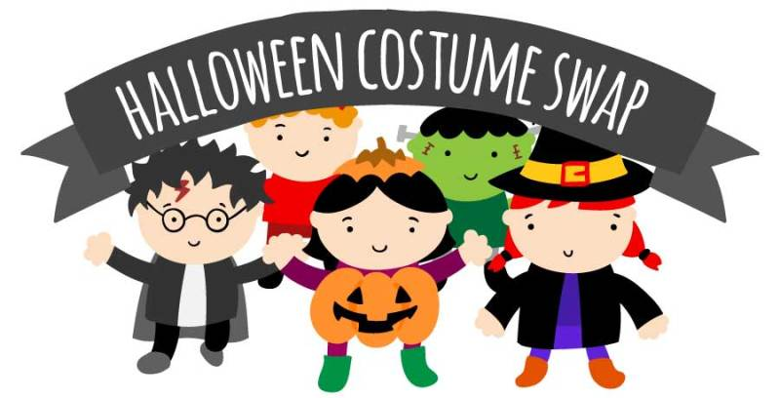

Wednesday, October 11, 4:00-7:00pm
Recreation Office, Six Park Row, Town Hall

WHO: Mansfield Residents and Non-Residents

WHAT: You are invited to join us for our Annual Halloween Costume Swap!

We will be accepting gently worn Halloween costumes in the Parks & Recreation Office up until the swap. Come back and visit us October 11th to see if your child can find a new costume for Halloween.

COST: You do not need to bring a costume to take a costume.
Free event.

