2023
Mansfield Parks & Recreation
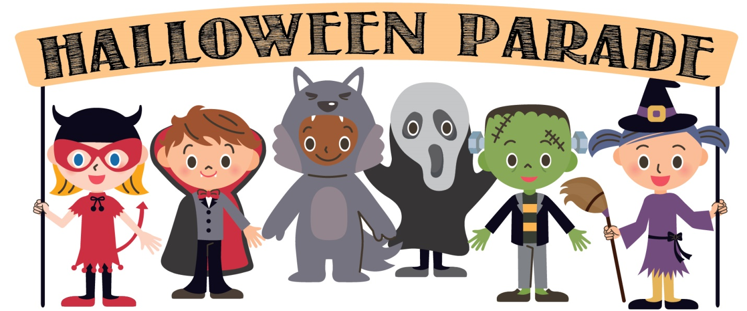

The Mansfield Parks & Recreation Department and Commission
invite you to attend our Annual Halloween Parade scheduled for
Saturday, October 28th, 11:00am on the South Common!

Dress in your best costume; winners will be awarded trophies in the following categories,

Most Original
Most Frightful
Best Duo/Group
George Dentino Spirit Award
Best Pet Costume

The parade route is as follows: Starting at the South Common, we will march down North Main Street, turn left on High Street, left on Rumford Avenue, left on West Street, right on Union Street and back onto the South Common.

This is a free event, no registration necessary, rain or shine.
We look forward to celebrating Halloween on a beautiful New England fall day!

508.851.6458 / recreation@mansfieldma.com

